Ms. Bohm’s Classroom Schedule

2024-2025

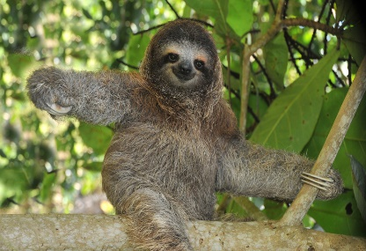

[This Photo](https://dearpersonreadingthis.blogspot.kr/2016_05_01_archive.html) by Unknown Author is licensed under [CC BY](https://creativecommons.org/licenses/by/3.0/)

|  |  |
| --- | --- |
| 8:20-8:30 | Arrival in Gym (Pledges/Announcements) |
| 8:30-9:00 | Classroom Routines (Put away belongings)  Journal Writing Prompt  Morning Meeting  Calendar/Weather  Heggerty Phonemic Awareness |
| 9:00-9:30 | ELA |
| 9:30-10:30 | ELA Small Groups/Centers |
| 10:30-10:45 | Writing Mini Lesson |
| 10:45-11:35 | Lunch/Recess |
| 11:35-11:55 | Meditation Monkey (Social Emotional Learning)  /Read Aloud |
| 11:55-12:15 | Writing Workshop/Conferences |
| 12:15-12:35 | Math |
| 12:35-1:05 | Math Small Groups/Centers |
| 1:10-2:00 | Ancillary |
| 2:00-2:15 | Snack/Read Aloud |
| 2:15-3:00 | Science/Social Studies |
| 3:00-3:17 | Afternoon Wrap Up/Dismissal |